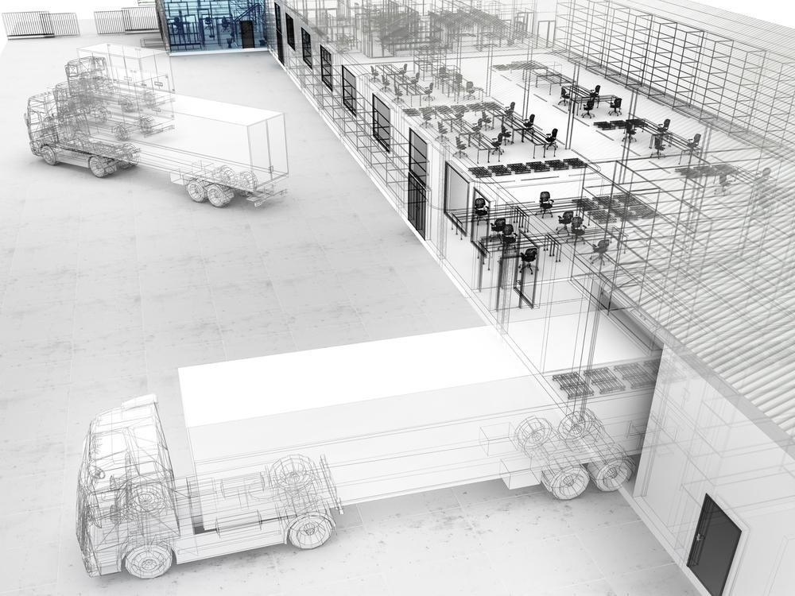

**Guide to re-labeling your warehouse for maximum efficiency**

Designing a labeling system for your warehouse might seem easy but it requires that you take many factors into consideration. If you’re like most companies, your racks have a series of legacy labeling from other times and other companies. The goal of an efficient locator management and rack labeling system is to provide an easy and intuitive method for your staff to quickly locate product throughout the warehouse while allowing for future growth and expansion.

This document assumes that you already have a warehouse in place and need to design a solution best suited for the existing layout. Had you had the option of a blank slate, we would have started with different questions that focused around the types of activity, products, and overall size of the facility.

Follow these steps and you’re quickly be on your way.

of activity, products, and overall size of the facility.

Follow these steps and you’re quickly be on your way.

**Quick Tips**

For more information or help with your warehouse labeling project, contact us at the information below:

<https://3PLInsight.com/>

Robert Ferreras

562-307-0070

[Robert@3PLInsight.com](mailto:Robert@3PLInsight.com)



**Step 1- Identify the types of storage equipment in your warehouse and understand your options.**

Most warehouses will have a mixture of all three of these types of storage equipment. The goal of this step is to help you understand the options based on the storage model you’re using in the warehouse.

**Pallet Racking**

Considerations include:

* How high are the racks installed in the warehouse?
  + Depending on your scanning distance, you may need to consider retro-reflective labels for pallet locations above 10 feet tall. Information on retro-reflective materials are provided later in this write-up.
  + 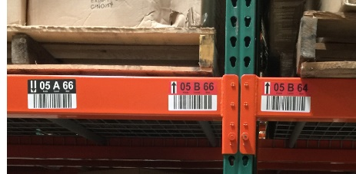You may also want to consider color coding the rack labels to make it easy for the user to identify a level. In this picture, the black label represents the ground floor while the red indicates the 2nd tier. This is especially helpful when you are putting away a pallet 3-5 levels high.
* Are you using rain guards or wire trays?
  + 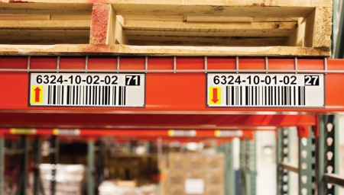Is wire guards are being used, you need to make sure that the scannable area of the bar code is located below it.
  + Sometimes it’s best to use a label that fits easily under the rain guard.
  + This image shows an example on how to use rack labeling in conjunction with rain guards.
* What is the max height of the horizontal beam?
  + This will determine the height of the label you need to use.

**Floor Stack/ Bulk Storage**

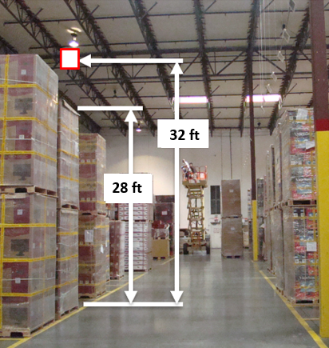Considerations Include:

* How high are you stacking pallets?
* Pallet stacking height largely depends on the weight and composition of the pallet. Knowing the maximum height will allow you to determine the height of the hanging sign.
* The height of the hanging sign coupled with the bulk location value you’re using will determine the size of the bar code in mils.
* This illustration shows a max pallet stack height of 28 feet and a max height of the bar-coded location sign of 32 feet. This gives the forklift operator enough space to maneuver when picking up or stacking pallets.
* Are you picking from both ends of the stack?
  + Knowing this determines whether you need hanging signs on both ends of the aisle or row of stacked pallets. In some cases, and depending on the length/depth of the pallet row, you might get away with hanging a double-sided sign in the middle of the row that can be scanned from either side.
* How tall is the warehouse ceiling?
  + This will give us a rough estimate on how much wire rope you’ll need to buy. Remember hanging signage needs to be measured from the floor to the sign and not the ceiling to the sign. Many warehouse ceilings are built at an angle and it is important to maintain the same distance from the ground up so that your scanners perform as needed.

**Metal Shelving**

Considerations include:

* How tall are the shelves stacked?
  + The height of the metal shelving will determine the make up of the label. The higher the shelves, the larger the human readable number needs to be so that it can be easily read by workers on the floor.
* What is the height of the surface area on the horizontal shelf?
  + This is important because shelf labeling is usually applied to the horizontal surface. You label needs to fit in that space and not overlap or it will eventually fall off.
* Are you picking from both ends of the shelf?
  + This will determine whether you need two sets of identical labels.
  + Depending on the inventory management system you have, some solutions will have the pick location number different from the puta-way when the racks have access to both ends. This allows the business to easily enforce FIFO rules.

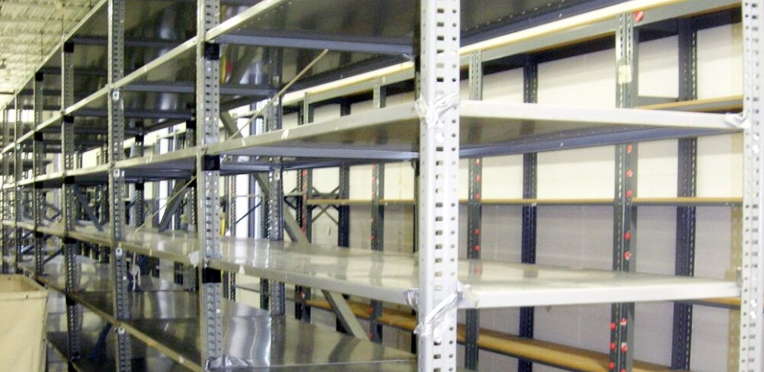

**Step 2- Identify the type of bar code scanning technology you’re using in the warehouse.**

This step is key to determining the type of labeling needed. If your forklifts take the worker up to the rack level, then distance if not a factor. However, if your forklift worker stays on the ground while the pallet is raised to the location high above, then the labeling solution needs to accommodate the ability to scan at long distances. The only other consideration in this case would be to use Totem Placards or vertical labels. More information about these types of labels are provided in this report.

**Short Range Scanners (1D and 2D)**

Considerations Include:

* Short range scanners are typically designed to scan labels at distances between 4 inches to 18 inches. This assumes you’re scanning a standard UPC type of label. Other codes will allow you to scan from longer distances.
* Short range scanning is used by workers that are scanning bar codes at short distances. This means whether you’re scanning from the ground level or in cases where the lifting equipment goes up with the individual, the bar code scan distance is always never greater than 6 feet.

**Long Range Scanners (1D and 2D)**

Considerations include:

* Long range scanners can pick up bar codes at distances ranging between 8 inches all the way up to 28 feet.
* Long range scanning is typically only used from the ground floor. Because the scanner has the ability to scan at great distances, the user can stay at ground level.

The illustration below will give you a good idea of how the location labeling impacts the scanning technology and why it is important to take these factors into consideration.

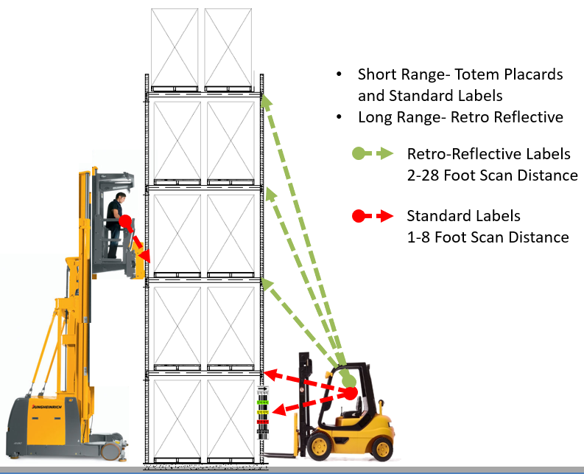

**Step 3- Determine a numbering sequence that best fits your layout.**

Now that you understand how your racking and scanning equipment plays into the labeling process, it’s time to determine a numbering scheme that makes sense for you. There is no right way of doing this but there are certainly many wrong ways. It is important that your location numbers can be easily read and interpreted quickly. Most warehouses will include the following elements in their location numbering sequence:

* **Warehouse ID**- This would be applicable for companies that have multiple warehouses or warehouses that are segmented by business type (ex: Manufacturing, Finished Goods) or by customer as a 3PL might consider. This is typically a 2-digit numeric value.
* **Row or Aisle**- Depending on which option you decided to use, either is usually a 2-digit number. There are not many warehouses with over 99 rows. Here some thing to consider when deciding on Row versus Aisle:

|  |  |
| --- | --- |
| **Aisle Numbering** | **Row Numbering** |
| This type of system numbers the aisles rather than the rows. For example, the illustration below shows how a you might layout your warehouse racks. By numbering the aisles, it allows you to create a zigzag sequence through the aisle where your workers will know that the odd number bays are on the left and the evens on the right. | This option numbers the actual rows of racks sequentially. There are no significant advantages to this option over the aisle numbering. It’s a matter of preference. My experience has shown that the aisle option is more intuitive. |
|  |  |

* **Level**- This applies to the vertical rack position. You’ll want to determine how to number the levels. This should be simple and easy for your warehouse staff to interpret. The two most common options are to either use numeric or alpha characters. If you use a number, always consider starting with “01” for your floor level. This gives you the option to add levels to your racking later without major implications.

A second option would be to use an alpha character. For example, using the letter “A”. Again, as in the previous option, have the “A” be your ground level. If you add levels, you merely jump to the next letter. There are few warehouses that I’ve seen with more than 26 levels so I don’t think this option will be a problem. Also using an alpha character in the location number makes it easy for the worker to determine what equipment is needed. For example, if I’m being directed to Aisle 01, Level C, Bay 22 (01 C 22) I can quickly determine that this pallet in on the right side of the aisle and third level up.

Here is an illustration on how this might appear:

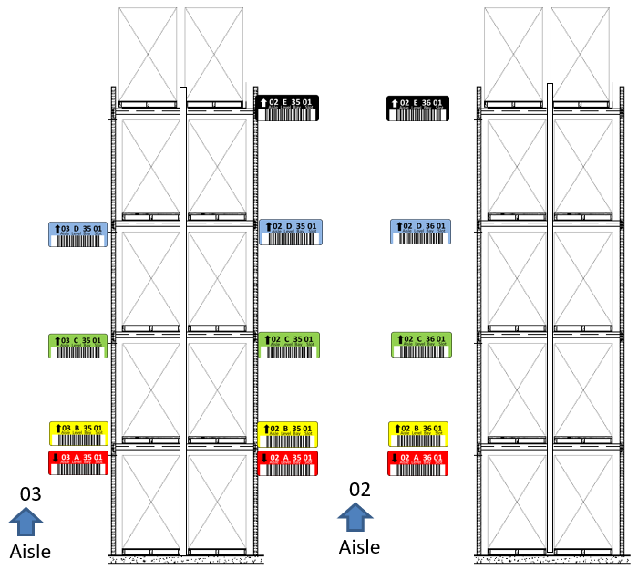

* **Bay** - When involving traditional pallet racking, Bay typically relates to a grouping of two pallet positions. In some cases, Bay and Slot represent the same location.
* **Slot**- Some companies want to track a slot position on a rack. Whether it involves a double wide or double deep, using a slot designator will help further define the location of the merchandise.
* **Bin**- Bin is typically the least common denominator in this equation. Some companies consider Bin and Slot to be the same.

Here are some numbering sequences to consider:

Notice that the elements are space to allow for someone to easily interpret the positions. Note that the larger the number the smaller it has to be printed. Also notice that the label contains a directional arrow. You need this to guide the warehouse worker. Especially when you place two labels in the same beam where one location is below and the other is above. And finally notice that we color coded the label. Again, we’re trying to make this as easy and intuitive as possible for anyone to look a location and know precisely where to go. If only street addresses were as easy.

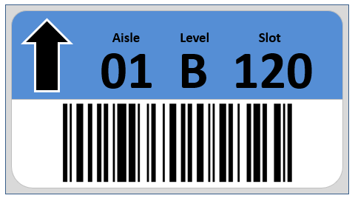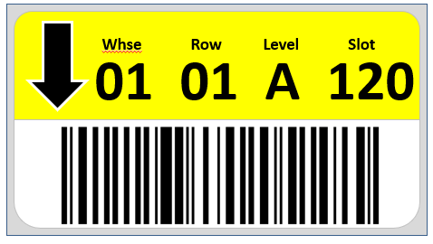

Now that you have decided on a location sequence, the next step is to create a database or table of these location numbers. Microsoft Excel is the perfect tool to create this template. In the example below, we created an excel worksheet with the location elements as the title of each column. We also added a Bar Code column which represents a concatenation of the four elements. We also have a column for the direction arrow and for quantity. The direction arrow value is usually “D” for down or “U” for up. The quantity field represents how many duplicates to print. If your racks are accessible from both sides, you’ll want to use the number 2.

It is worth noting that when using excel and enter the value of 01, you actually have to type in ’01 so that excel knows to keep both digits. Otherwise, it will remove the leading zero and set the value to 1.

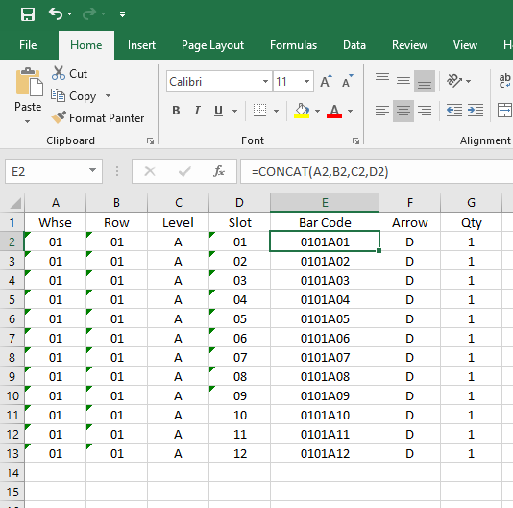

**Step 4- Choosing the types of location labels or signage.**

The final step in this process is to select from the various types of location labels available.

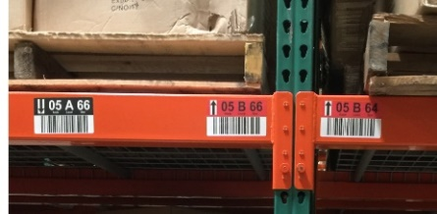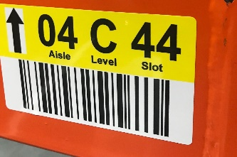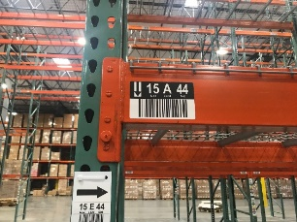**Pallet Racking- Short Range Scanning**

Pallet rack labels should be easy to read at first glance. The design should be simple and include the elements mentioned earlier. These labels also have to be very rugged and need to survive scratching, rubbing, and contact with warehouse equipment. Having said this, it is obvious that you want to position the labels in a spot where they’re less likely to be damaged.

|  |  |  |
| --- | --- | --- |
| Questions | Considerations | Common Answers: |
| What size label would best fit your rack? | Consider rain guards and the height of your horizontal beams | □ 4x3  □ 5x2  □ 5x3 (Pictured) |
| Should I use color? | Color adds to the inventory accuracy because it makes it easier for the staff to locate. | □ Red  □ Yellow  □ Green  □ Black  □ White |

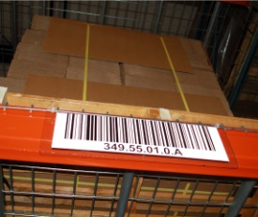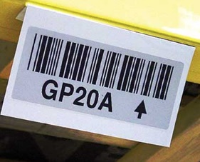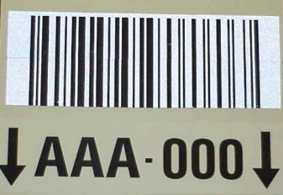**Pallet Racking- Retro-Reflective Long-Range Scanning**

Retro-reflective labels are special label material designed for scanning at long range distances. This material contains glass like particles that amplify the light from a scanner and allows the scanner to decode the values at much greater distances. General rule of thumb is that these should be used for any pallet racking locations above 14 feet.

|  |  |  |
| --- | --- | --- |
| Questions | Considerations | Common Answers: |
| What size label would best fit your rack? | For long range scanning the size of the label will be determined by the size of the bar-coded value and the distance you expect to read the barcode. For example, a standard 5-tier pallet rack is about 22 feet tall. A six-digit location number would easily fit in a 4x3 format. If your location number is larger, then you’ll want to start with a 5x2 label. | □ 4x3  □ 5x2  □ 5x3  □ 6x2.5  □ 8x2.5  □ 8x3 |
| Should I use color? | The actual retro-reflective bar-coded area of a label cannot contain color. You can use a two-piece label if you truly need a color retro-reflective label. | □ Red  □ Yellow  □ Green  □ Black  □ White |

**Pallet Racking- Magnetic Labels**

Magnetic labels offer an easy and quick option to install your labels. While this is an advantage, the disadvantage is that they can just as easily be removed. Folks that elect to use magnetic labels prefer to flexibility and mobility to move the locations around when needed. For example, if you need to expand a section with more location, you merely remove the magnets that don’t apply and store them for later use.

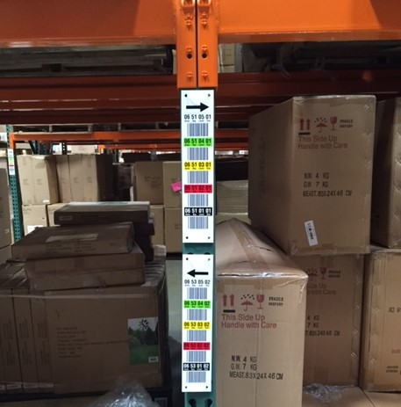**Pallet Racking- Totem Placards or Vertical Column Labels**

Vertical labels are a very effective method of labeling a warehouse rack. This option allows the user to see all the available location numbers on one label or placard. Color coding the levels makes it even more intuitive for the warehouse staff to locate products.

This configuration also allows the user to use a short-range bar code scanner. Most of the time however, customer will use totem placards in conjunction with color coded rack labels. Specially in narrow aisle dense racking where the forklift goes up with the driver, having a local bar code to scan increases their productivity.

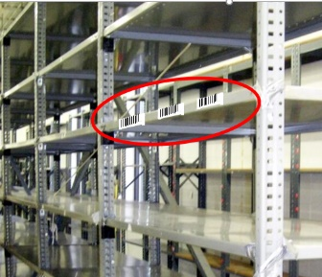**Metal Shelf Labels**

Metal Shelf Labels are very inexpensive and easy to apply. Typically, these labels will be monochrome in color, meaning black print on a white background. The only thing you have to worry about is that the height of the label needs to be less than the height of the horizontal shelf.

**Hanging Signs**

One of the best ways to track locations in a bulk pallet stack area is to use hanging signs. Hanging signs consist of a large retro-reflective label applied to a plastic PVC style sign. The sign will almost always contain a bend angle to allow the scanning surface to hang at a 30-degree angle.

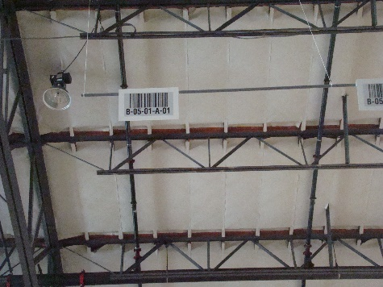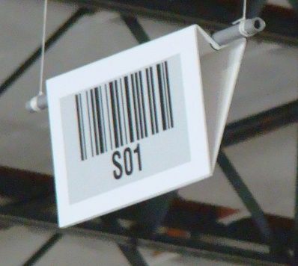

Now that you have a better understanding of the options available, call us and we will help you through this process. While this is not a difficult process, it is one that requires experience and know how. We’ve installed hundreds of warehouse locator systems over the past 20 years.

Visit our website at: <https://3PLInsight.com/warehouse-rack-labels>

For more information, contact:

Robert Ferreras

[Robert@3plinsight.com](mailto:Robert@3plinsight.com)

562-307-0070